5.6

a) (35-3=32) (18+19=37) (37-32 = 5) so 5 people take both Spanish and French lessons.

b) (19-5=14) so 14 people take only Spanish lessons.

c) (18-5=13) so 13 people take only French lessons.

5.10

a) All encrypted files are secure. Some malicious files are not encrypted. Therefore, some malicious files are not secure.

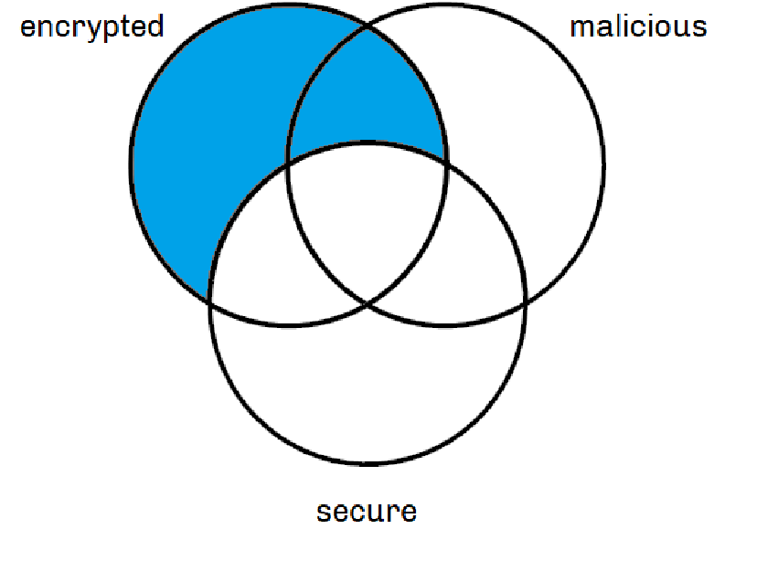dus kan je de conclusie trekken ‘therefore, some malicious files are not secure’

b) Some gamers are rich. No teachers are rich. Therefore, some teachers are not gamers.

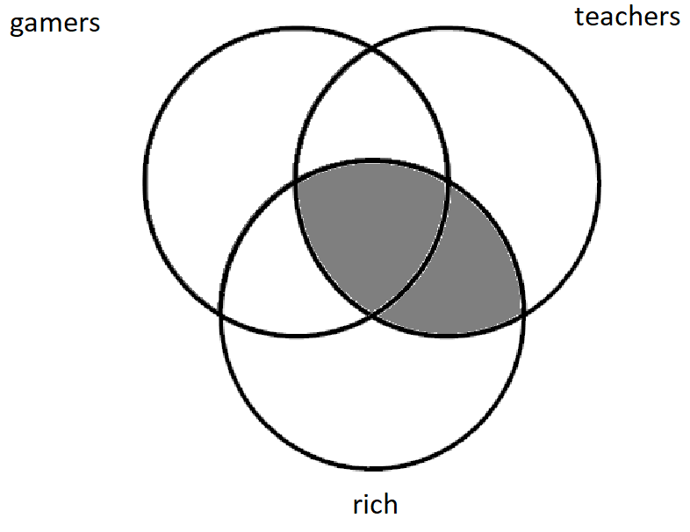dus kan je de conclusie trekken dat ’some teachers are not gamers’

c)  No elephants fly. None of my pets are elephants. Therefore, all of my pets fly.

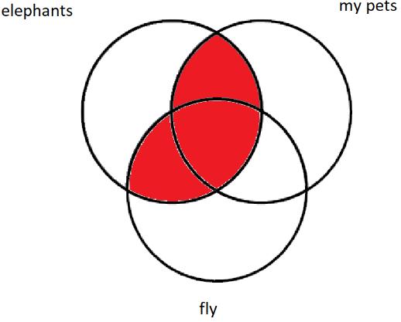

dus kan je de conclusie trekken dat ‘Therefore, all of my pets fly.’

d) Nobody who is illogical can run a country. All politicians are illogical. Therefore, no politician can run a country.

dus kan je de conclusie trekken dat 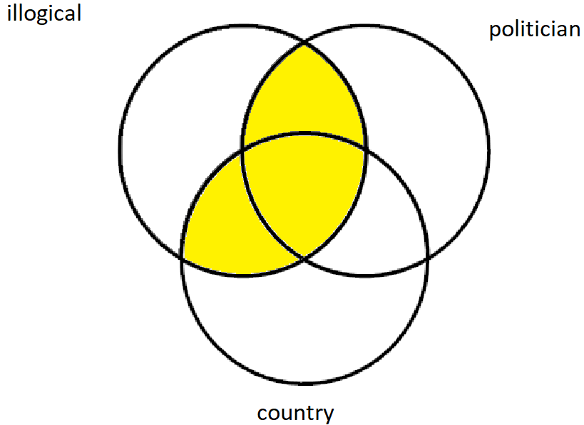‘ Therefore, no politician can run a country.’

e) No idlers win fame. Some painters are not idle. Therefore, some painters win fame.

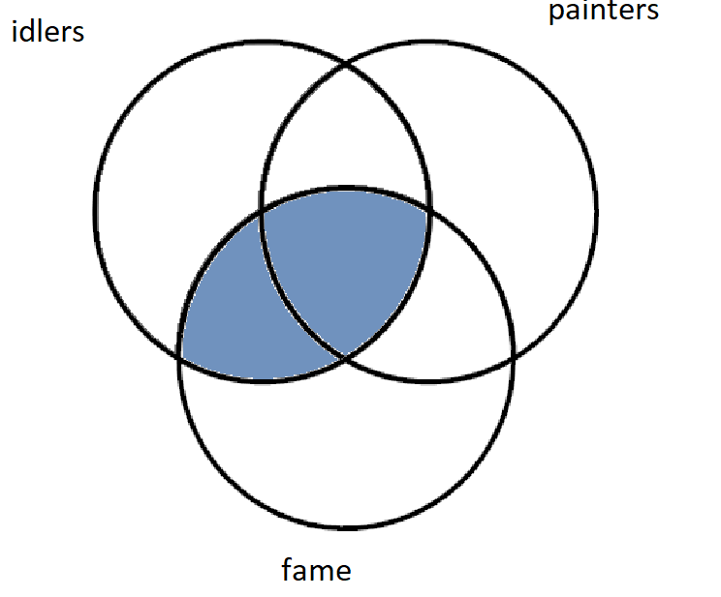

7.10

list = input('Please enter a list of integers: ')

n = len(list)

for i in range(n - 1):

if list[i] > list[i+1]:

check = True

else:

check = False

break

if check == True:

print('This list is in a decending order')

else:

print('This list in not in a decending order')

7.16

N = int(input("give the amount of Fibonacci numbers that you want: "))

number = 1

A = [1]

for i in range(0, N - 1):

fibonnaci = number + A[-1]

A.append(fibonnaci)

number = A[-2]

print(A)